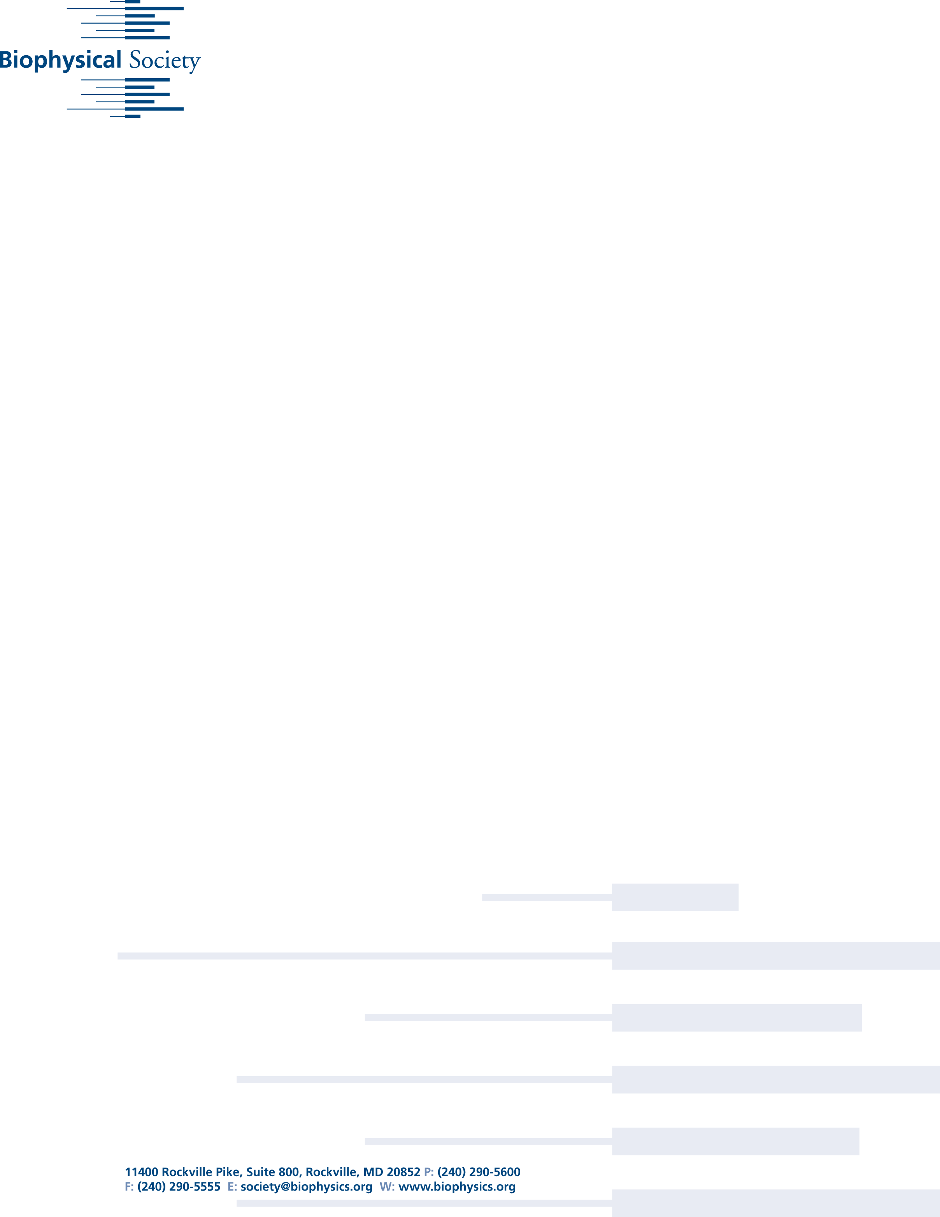

# Biophysical Society 60th Meeting, Feb. 27 - March 2, 2016, Los Angeles

**Using Graphene to Fight Bacteria**

***New wonder material may be a new, greener way to prevent deadly hospital-acquired infections of tomorrow -- work to be presented at the annual meeting of the Biophysical Society this week in Los Angeles.***

-----------------------------

EMBARGOED for release until 4:30 p.m. Eastern Time on Wednesday, March 2, 2016

-----------------------------

For More Information:

AIP Media Line

media@aip.org

301-209-3090

WASHINGTON, D.C., March 2, 2016 -- New research on graphene oxide may one day transform our ability to fight infections acquired in the hospital and elsewhere.

Scientists at the Università Cattolica del Sacro Cuore in Rome are studying graphene oxide in the hopes of one day creating bacteria-killing catheters and medical devices. Coating surgical tools with this carbon-based compound could kill bacteria, reducing the need for antibiotics, decreasing the rates of post-operative infections and speeding recovery times.

Graphene is a new wonder material first characterized in the last decade -- work recognized with the 2010 Nobel Prize in physics. This single-atom-thin sheet material holds promise in future electronics, battery and manufacturing technologies.

“We want to make materials that will help patients and medical professionals,” said Valentina Palmieri, a biotechnologist at the Università Cattolica del Sacro Cuore in Rome.

Graphene oxide, a form of graphene with molecular oxygen incorporated into it, protects against infection by destroying

Date

Dear

Insert text here.



bacteria before it gets inside the body. The graphene oxide wraps around the bacteria, puncturing its membrane. A broken membrane prevents the bacteria from growing and often kills it. “The bacteria lose their complex structure and die,” Palmieri added. “And since graphene is just carbon -- a building block of life -- its cytotoxicity against human cells is much lower compared to any drug-based antimicrobial therapy.”

Researchers decided to use graphene oxide because it is very stable in a water solution, making it safe to interact with human cells. Graphene specifically attacks bacterial cells, while sparing human cells, and the mechanism behind this specificity is still unclear, Palmieri said. Current theories include that the material interacts more favorably with the bacterial cell wall or that mammalian cells have evolved multiple repair mechanisms to survive the chemical oxidation damage that graphene induces.

Graphene is also more eco-friendly. Traditional methods of preventing infection include antibiotic therapy and tools coated with silver -- both of which are toxic to the environment, Palmieri said.

The compound is most effective when paired with salt. Too little salt and the graphene oxide won’t wrap around the bacteria. Too much salt and the graphene aggregates, failing to puncture the bacteria’s membrane. To destroy both Gram positive and Gram negative bacteria, two major categories of bacteria to which many hospital-acquired pathogens belong, a 300 nanometer sheet of graphene oxide solution must be mixed with low molarity (<10 mM) Calcium chloride.

Palmieri and her team also created new protocol methods for testing the effectiveness of the graphene oxide and salt mixture. Researchers normally use a spectrophotometer to test whether the solution has killed all the bacteria. This method didn’t account for any bacteria that may have fallen to the bottom of the solution. Instead, Palmieri uses two different wavelengths of light -- one that is sensitive to absorbing and one that is sensitive to scattering -- to check for bacteria.

The next step is to test graphene oxide's effectiveness against fungi. Fungi can also cause significant problems if they infect an open wound. Up until this point, though, fungi cells are too big for graphene oxide to wrap all the way around them. Palmieri says she wants to alter the salt content inside the saline solution to see if she can solve this issue.

Presentation #2610, "Towards a “green” antimicrobial therapy: Study of graphene nanosheets interaction with human pathogens," is authored by Valentina Palmieri, Massimiliano Papi, Francesca Bugli, Mariacarmela Lauriola, Claudio Conti, Gabriele Ciasca, Giuseppe Maulucci, Maurizio Sanguinetti and Marco De Spirito. It will be at 1:30 p.m. PT on Wed., March 2, 2016 in Room 501ABC of the Los Angeles Convention Center. ABSTRACT: <http://tinyurl.com/zzgsofu>

-------------------

MORE MEETING INFORMATION

-------------------

ABOUT THE MEETING

Each year, the Biophysical Society Annual Meeting brings together more than 6,500 researchers working in the multidisciplinary fields representing biophysics. With more than 3,600 poster presentations, over 200 exhibits, and more than 20 symposia, the BPS Annual Meeting is the largest meeting of biophysicists in the world. Despite its size, the meeting retains its small-meeting flavor through its subgroup symposia, platform sessions, social activities and committee programs. The 60th Annual Meeting will be held at the Los Angeles Convention Center.

**PRESS REGISTRATION**

The Biophysical Society invites professional journalists, freelance science writers and public information officers to attend its Annual Meeting free of charge. For press registration, contact Ellen Weiss <EWeiss@biophysics.org> or the media line at the American Institute of Physics at <media@aip.org> or 301-209-3090.

**NEWS RELEASES**

Embargoed press releases describing in detail some of the breakthroughs to be discussed at the meeting are available on Eurekalert, Newswise and Alpha Galileo or by contacting the media line at the American Institute of Physics at <media@aip.org> or 301-209-3090.

**QUICK LINKS**

Main Meeting Page: http://tinyurl.com/hewekyj

Symposia: http://tinyurl.com/h7lnk4p

Itinerary planner: http://tinyurl.com/hslnx3p

**ABOUT THE SOCIETY**

The Biophysical Society, founded in 1958, is a professional, scientific Society established to encourage development and dissemination of knowledge in biophysics. The Society promotes growth in this expanding field through its annual meeting, monthly journal, and committee and outreach activities. Its 9,000 members are located throughout the U.S. and the world, where they teach and conduct research in colleges, universities, laboratories, government agencies, and industry. For more information on the Society, or the 2016 Annual Meeting, visit http://www.biophysics.org

####



platform sessions, social activities and committee programs. The 60th Annual Meeting will be held at the Los Angeles Convention Center.

PRESS REGISTRATION

The Biophysical Society invites professional journalists, freelance science writers and public information officers to attend its Annual Meeting free of charge. For press registration, contact Ellen Weiss <EWeiss@biophysics.org> or the media line at the American Institute of Physics at <media@aip.org> or 301-209-3090.

NEWS RELEASES

Embargoed press releases describing in detail some of the breakthroughs to be discussed at the meeting are available on Eurekalert, Newswise and Alpha Galileo or by contacting the media line at the American Institute of Physics at <media@aip.org> or 301-209-3090.

QUICK LINKS

Main Meeting Page: <http://tinyurl.com/hewekyj>

Symposia: <http://tinyurl.com/h7lnk4p>

Itinerary planner: <http://tinyurl.com/hslnx3p>

ABOUT THE SOCIETY

The Biophysical Society, founded in 1958, is a professional, scientific Society established to encourage development and dissemination of knowledge in biophysics. The Society promotes growth in this expanding field through its annual meeting, monthly journal, and committee and outreach activities. Its 9,000 members are located throughout the U.S. and the world, where they teach and conduct research in colleges, universities, laboratories, government agencies, and industry. For more information on the Society, or the 2016 Annual Meeting, visit http://www.biophysics.org

####